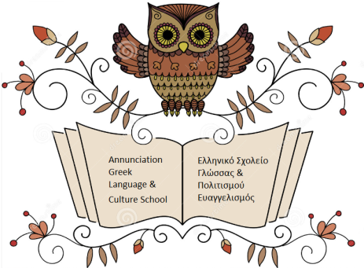

The Annunciation Greek Language & Culture School

Invites you to

Take a Course in Modern Greek

Adults (ages 15+)

Fall Semester 2018

Beginners, Intermediate & Advanced Classes
First class: Tuesday, September 25, 2018 (6:30 - 8:30 pm)

Advanced and Conversation Classes
First class: Thursday, September 20, 2018 (11:00am - 1:00pm)

Tuition per semester is $440.00. Tuition per year is $830 if paid in advance for both the fall and spring semester. We also offer a family discount. Students attending classes for the first time will need to purchase the class textbook and required workbook ($65.00), which they will use for 4 semesters. A minimum of six students is required for each class to form. We reserve the right to cancel the class, change the time, day, or transfer students to another group as needed.

For more information or any questions, please contact:

Katerina Kontogeorgaki at 832-242-9257 or email: Katerinakonto@agoc.org

